**Documentation for Funnel Chart Library**

# Objective of the library

The objective of this library is to build a funnel chart based on user defined input. This chart will show the flow of the inputs in a funnel like object inside a webpage.

# Technology Used

HTML5, AngularJs

# How to use

To use the library, users have to follow the steps described below:

* At first the user must open the **funnel_chart.html** in any text editor.
* Then he/she has to check whether **angularjs script** file, **angularscript.js**, **angular_library.js** are already included inside **funnel_chart.html** file. If no, then he/she has to add them in the following manner:

* After the inclusion of the .js files, open the **angularscript.js** file in any text editor.
* Then insert your canvas id as the first parameter of **library._$runchart()** function.A close up of a logo

  Description automatically generated
* Users can add their inputs or modify the existing ones according to their will. Input must be a JSON array. The following code snippet shows an input array: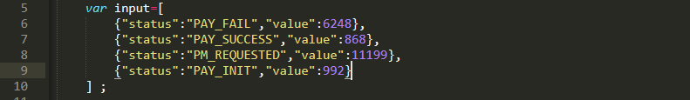
* Then pass the desired input as the second parameter of **library._$runchart()** function.A picture containing object

  Description automatically generated
* Then users can configure view of the canvas of the chart by customizing the **config** object**.**